**ANALYZING THE PERFORMANCE AND EFFICIENCY OF THE RADISSON HOTELS USING DATA VISUALIZATION TECHNIQUE**

1. **INTRODUCTION**

**1.1 Overview**

This project gives overview on analysing the performance and efficiency of the Radisson hotels using data visualization technique. Where Visualization of total revenue for hotels, successful booking data wise, successful booking by city, occupancy by date type, revenue by room class, revenue split by city, occupancy split by city.

**1.2 Purpose**

This project is used to calculate the total revenue for hotel and also helps to find out which hotel has more occupancy by city and used to calculate the hotel revenue by room class. By using this project, we can achieve the successful booking by city and can able to find out the booking percentage by platform. And also this project used to calculate total revenue for hotel and which category has highest revenue. By using this project, we achieve the successful booking by date wise.

**2. PROBLEM DEFINITION AND DEFINE THINKING**

**2.1 Empathy mapping**

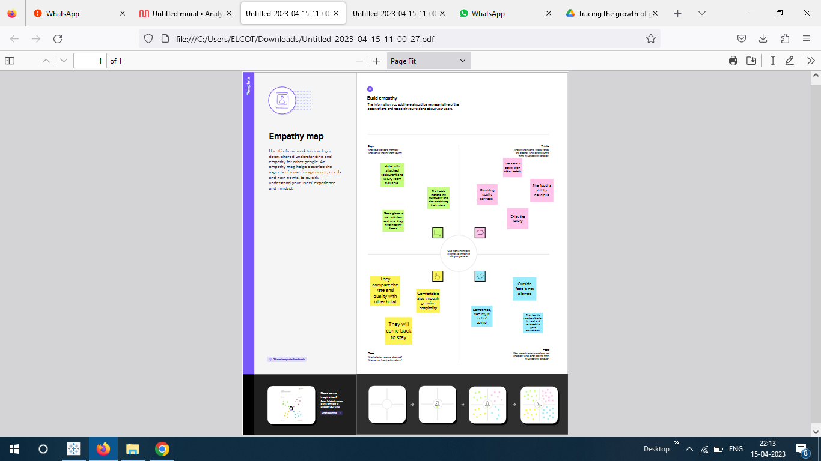

* 1. **Ideation and brainstorming map**

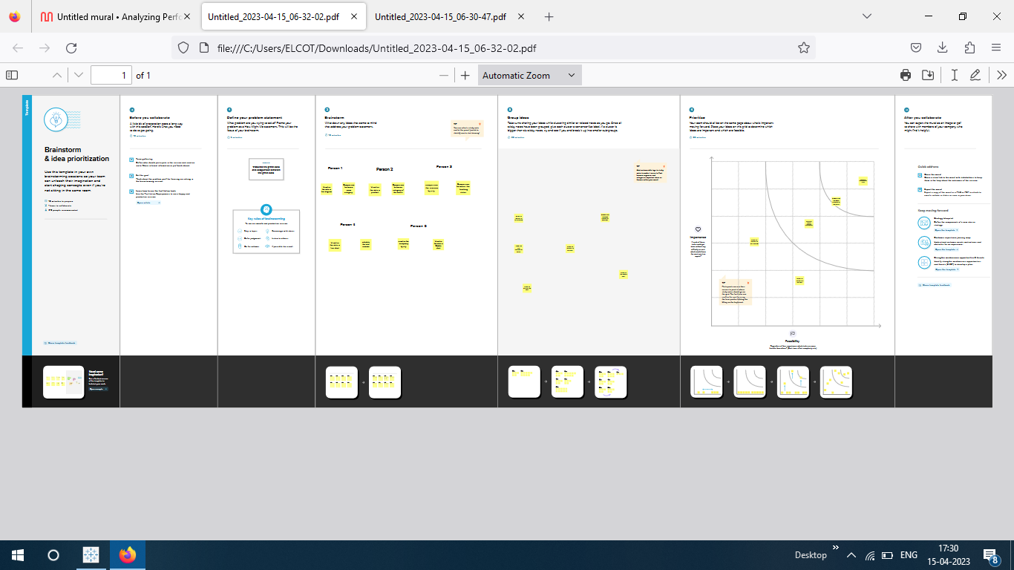

3.RESULT

By the analysis of the project we find that Mumbai has made highest number of successful booking-43,445. Elite and premium room class are the top two highest revenue contributors. Other platforms and make your trip contributed 42% of the total checked out bookings. All properties have average 25% cancellation rate and 50% Occupancy rate.

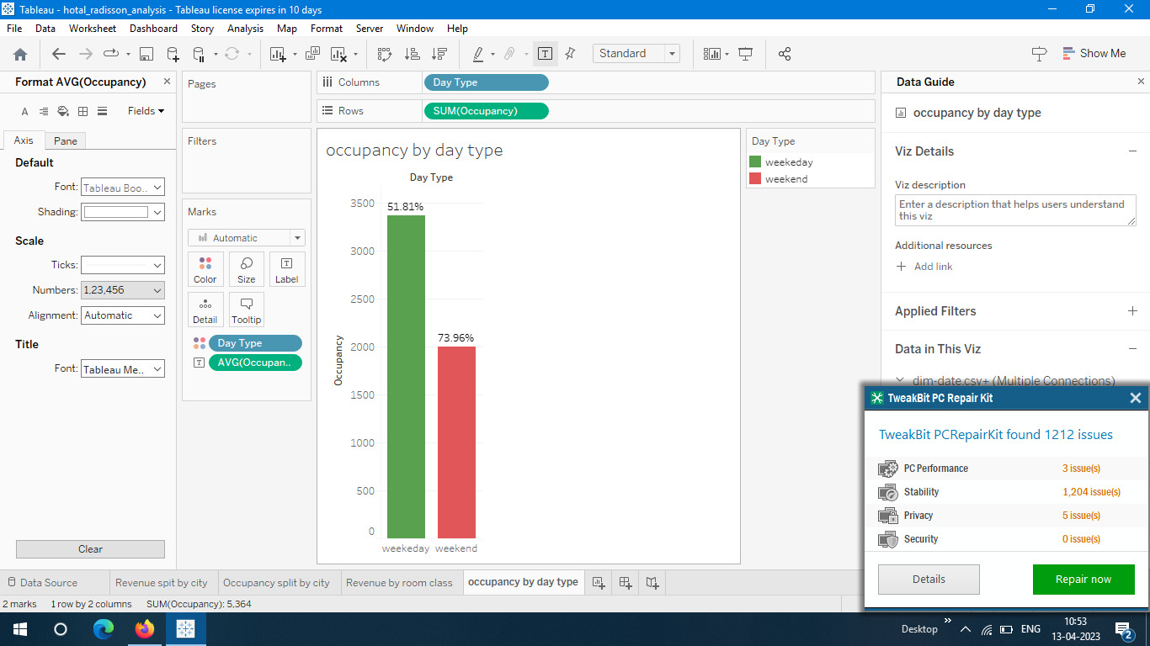

1. 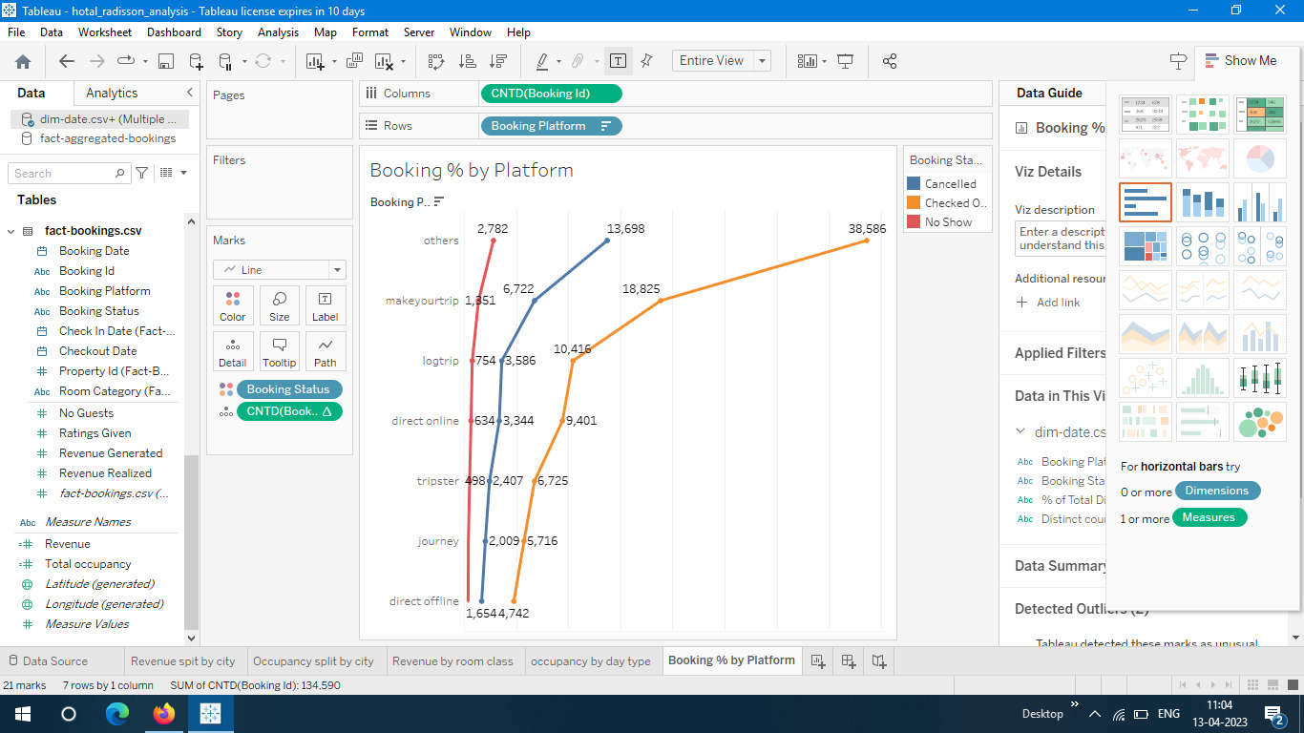

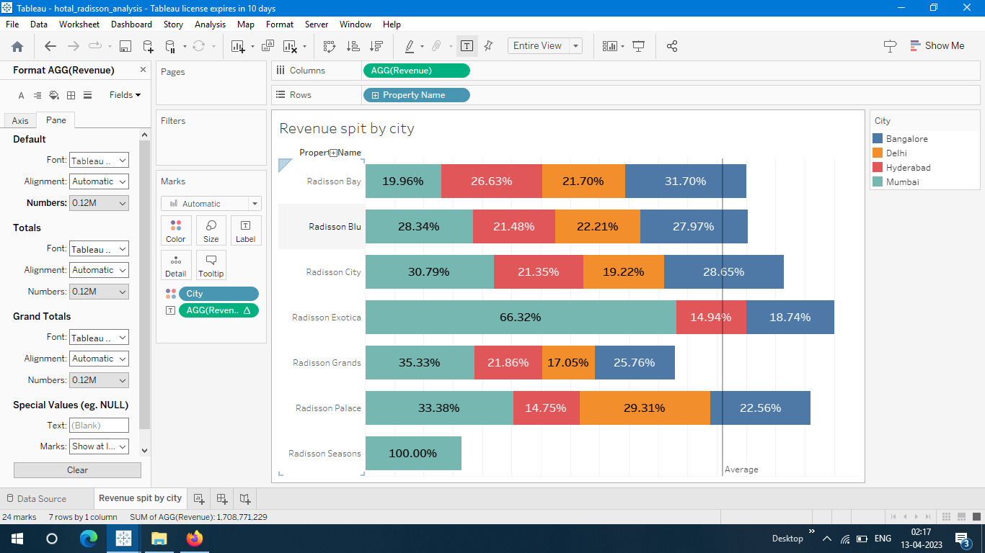

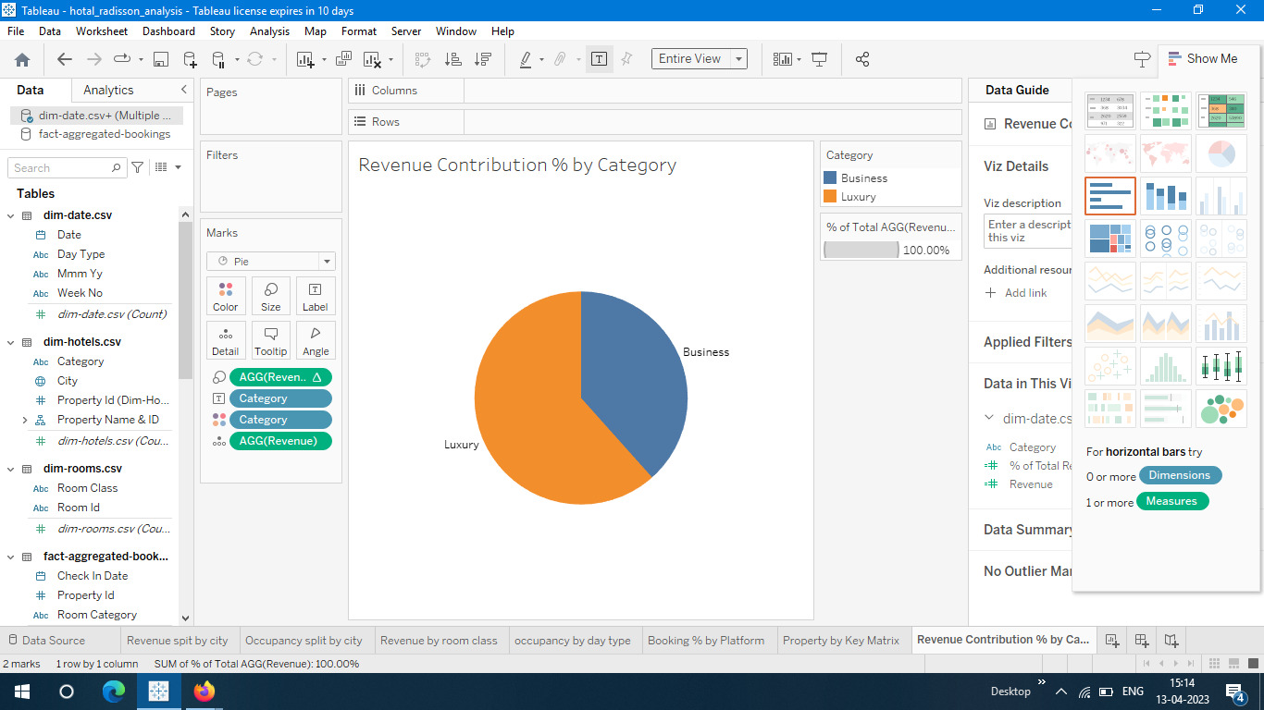

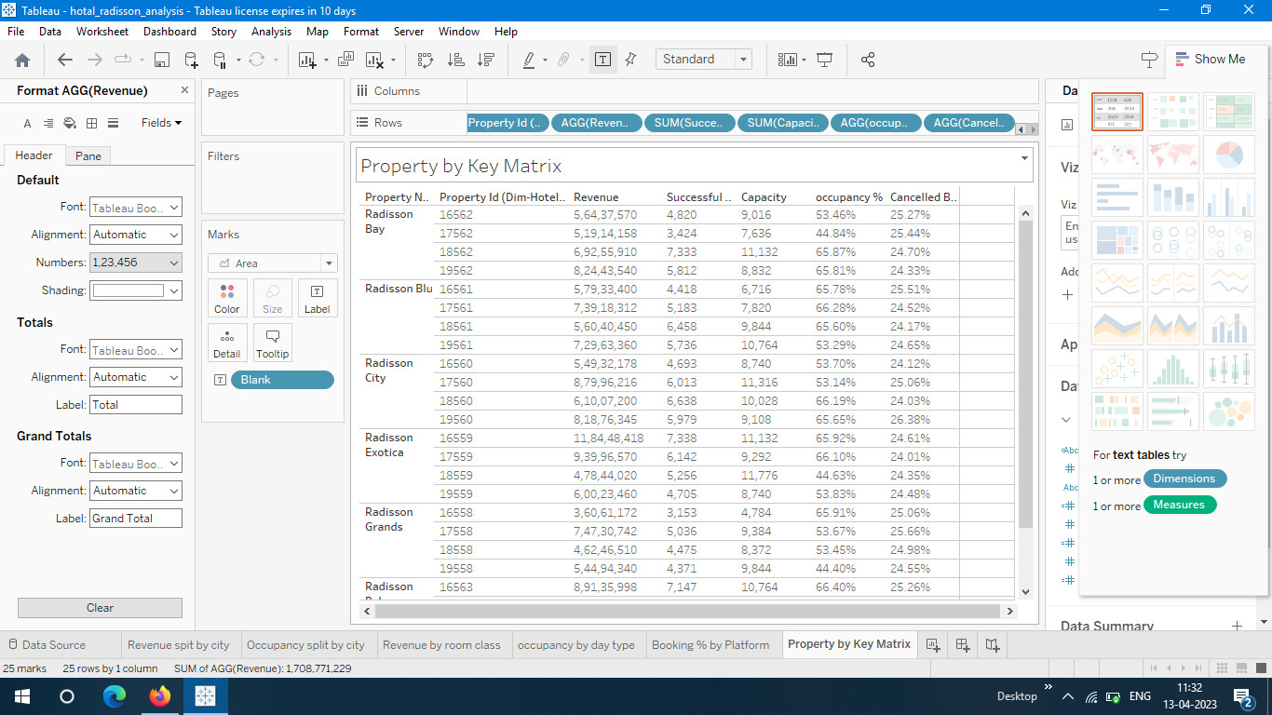

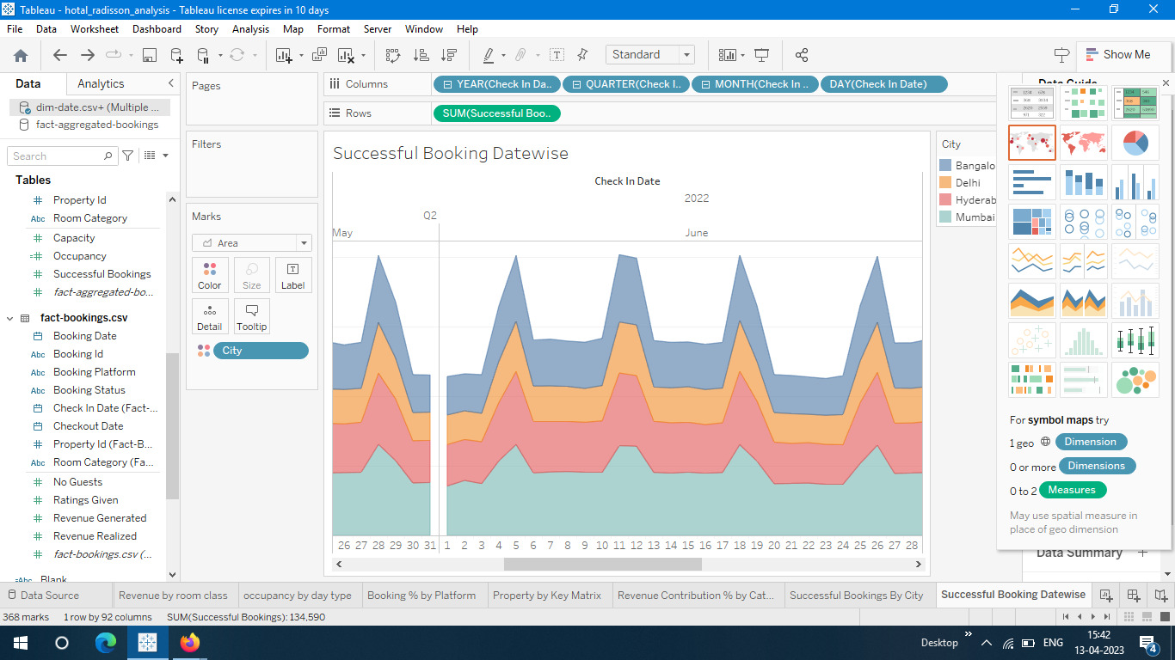

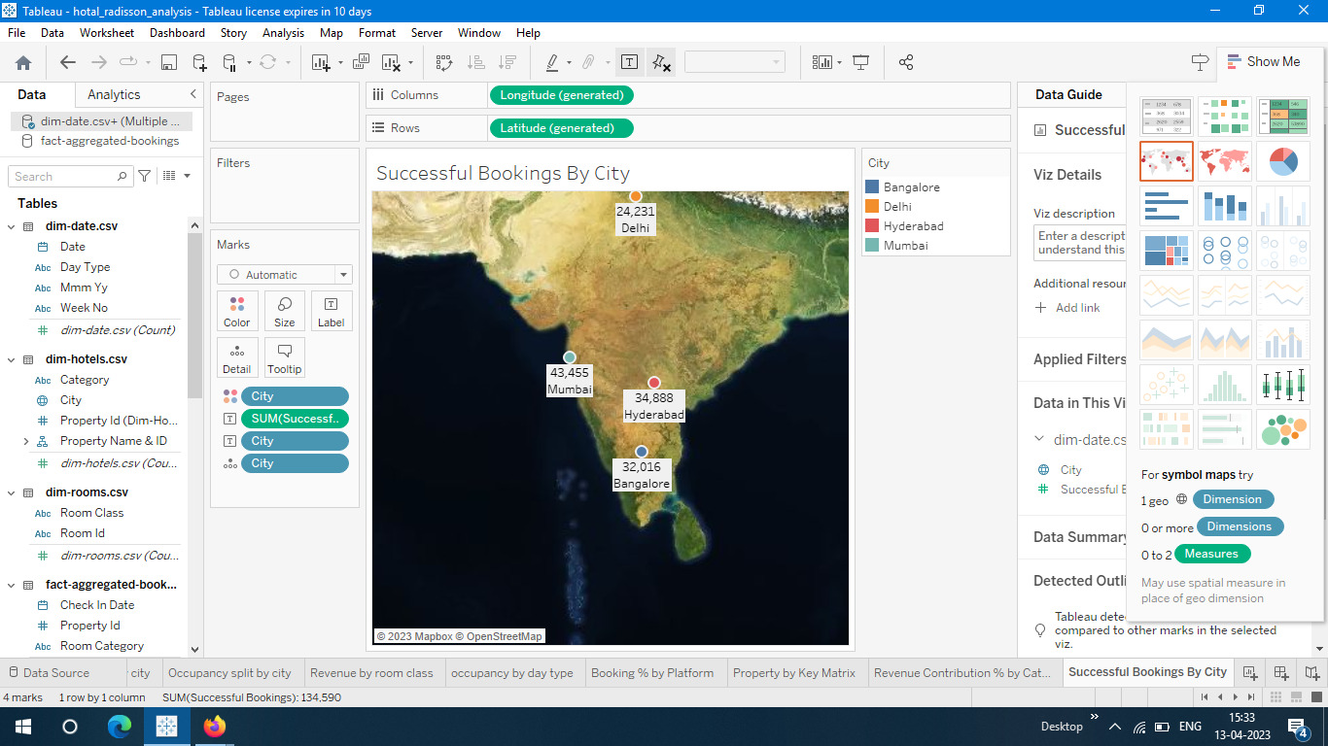

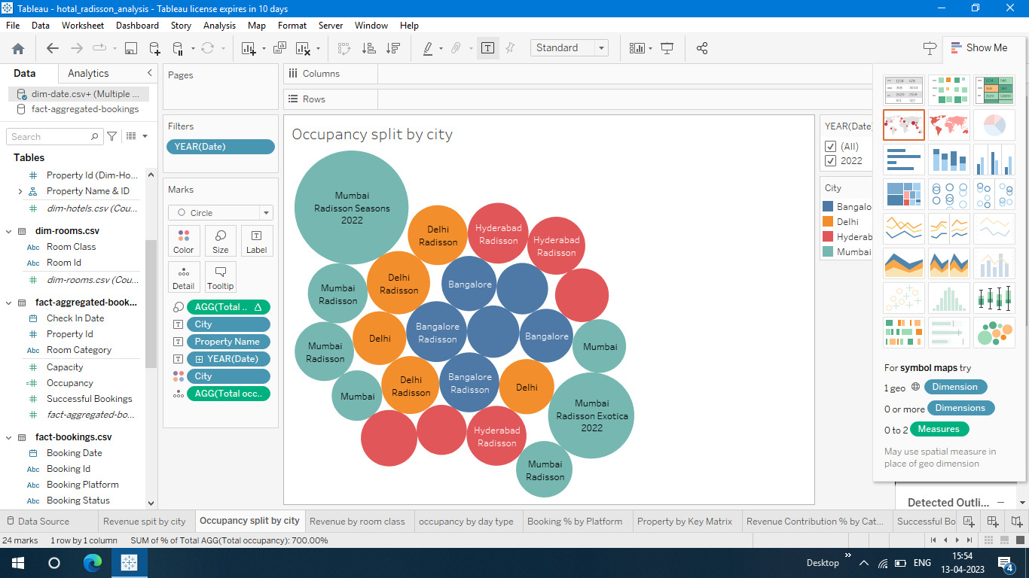

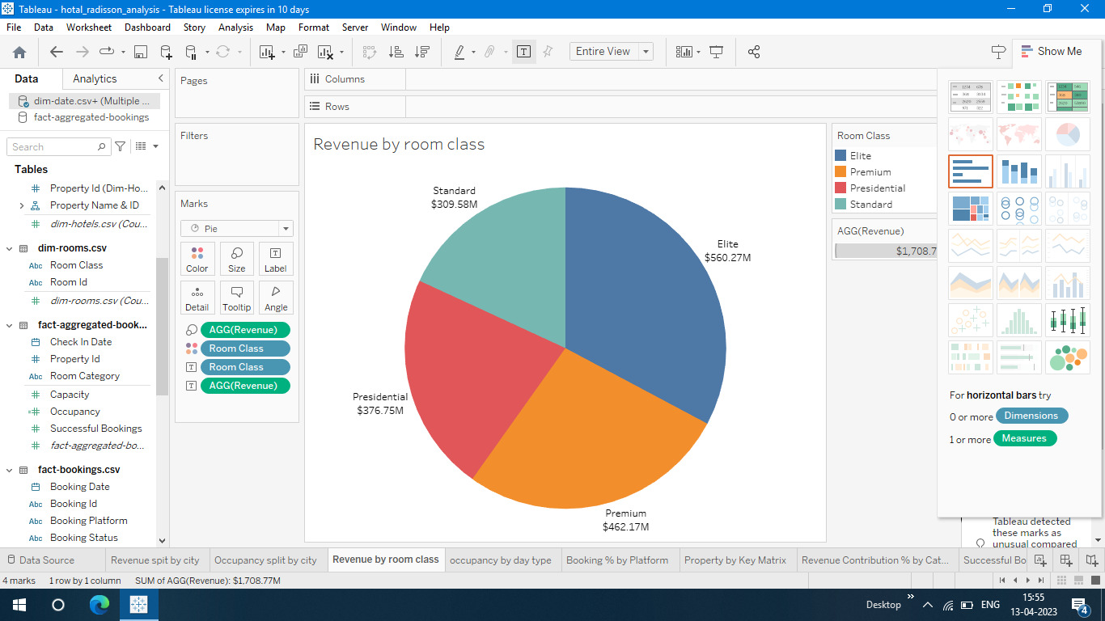

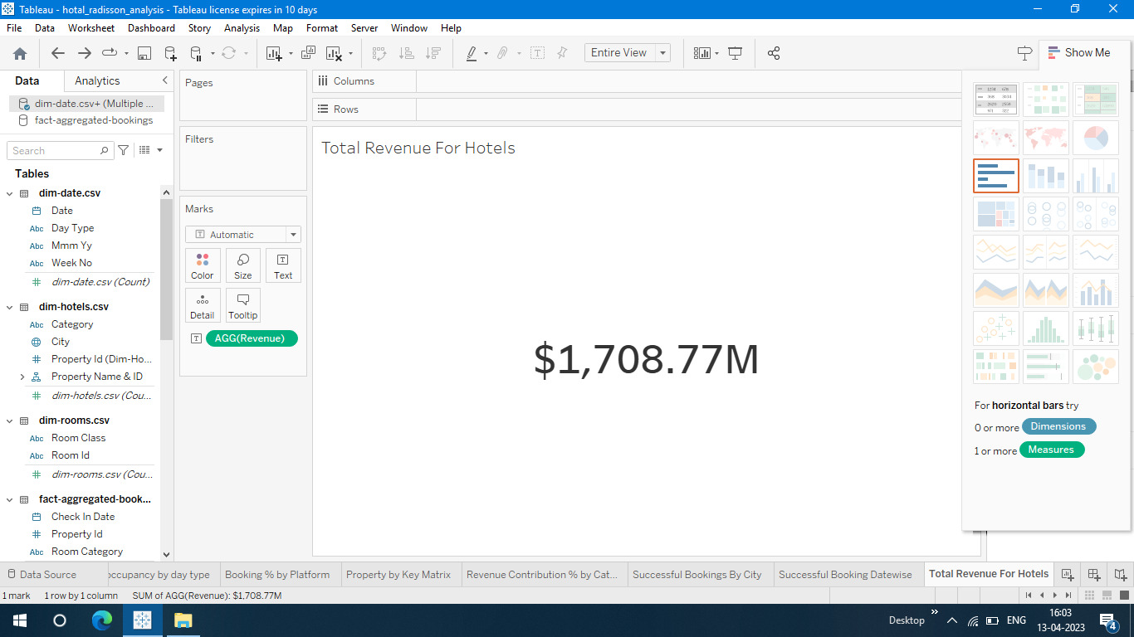

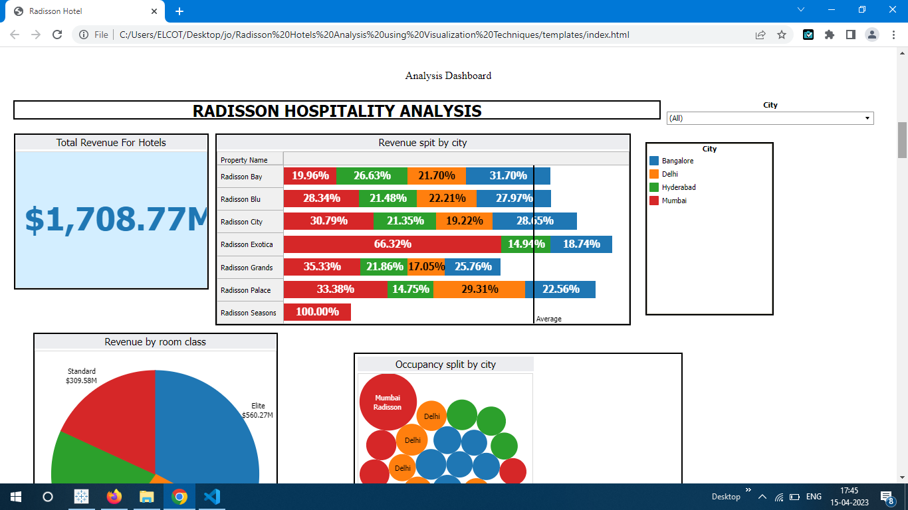

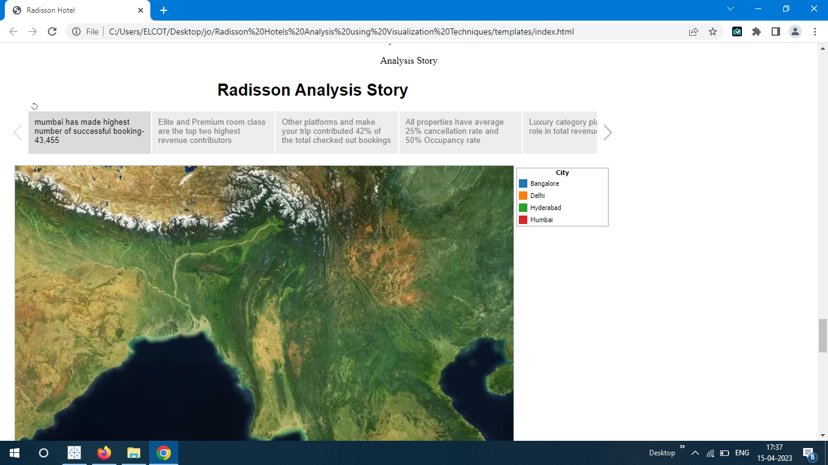

**4.ADVANTAGE AND DISADVANTAGE:**

**ADVANTAGES:**

1. In this we gain the knowledge about which city has highest revenue by Radisson hotels.
2. We get successful bookings by city in this project and it is applicable for find the Radisson hotel in better location.
3. In this we find total revenues for Radisson hotel.
4. And we calculated the successful booking by date wise, by using this we can say in which season has more successful bookings.
5. By using pie chart, we visualize which room class has highest revenue.

**DISADVANTAGE:**

1.By this project people can easily find out which hotel in top position and this is drawback to other hotels.

**5. APPLICATION:**

1.Evaluate hotels past financial performance.

2.Forecast a hotels future net income and cash floor.

3.Explain appropriate analyst adjustment to a hotel’s financial statement to facilitate comparison with another hotel.

4. Can able to compare the revenue, successful bookings, occupancy with other hotels.

**6.CONCLUSION:**

Mumbai has made highest number of successful bookings 43,455. Elite and premium room class are the top to highest revenue contributors. Other platforms and make your trip contributor 42% of the total checked out bookings. All properties have average 25% cancellation rate and 50% occupancy rate. Luxury category plays major role in total revenue. The total of all hotels is $1,708.77 M. In 2022 Mumbai Radisson season and Mumbai Radisson exotica have highest occupancy.

1. **FUTURE SCOPE:**

Future scope of this project is the peoples can choice the best hotel in suitable place and also can select easily the better room class.

**8. APPENDIX:**

file:///C:/Users/ELCOT/Desktop/jo/Radisson%20Hotels%20Analysis%20using%20Visualization%20Techniques/templates/index.html